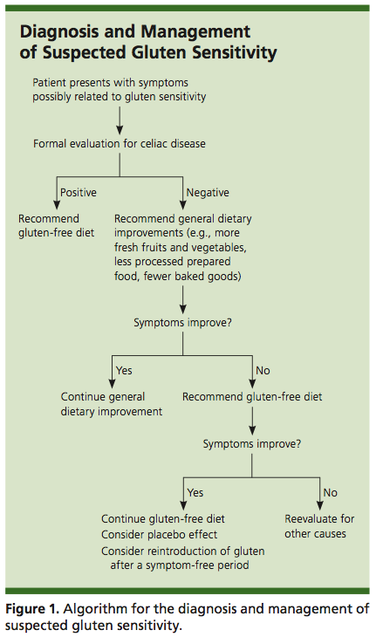

(source: McCarter CF. Non-celiac gluten sensitivity: important diagnosis or dietary fad? American Family Physician (2014). 11 May 14. 89(2).)

Note: in absence of celiac disease or non-celiac gluten sensitivity, a gluten-free diet is not healthier than a similar diet of gluten-containing foods, and there is no evidence that gluten-free diets result in weight loss.

