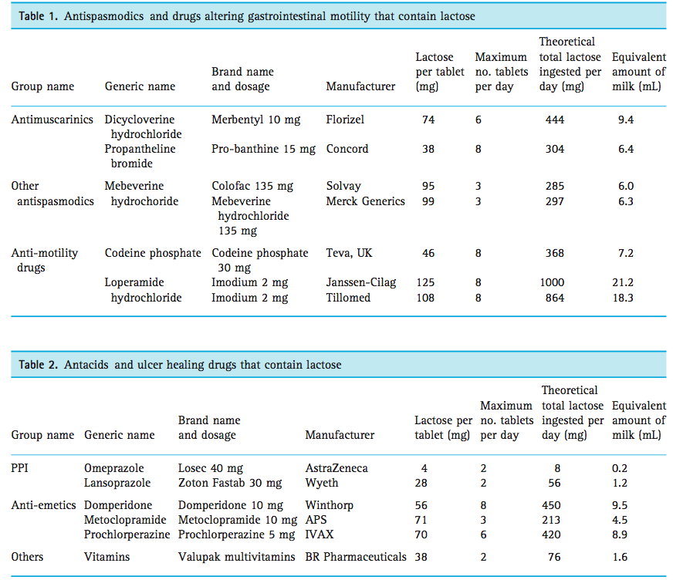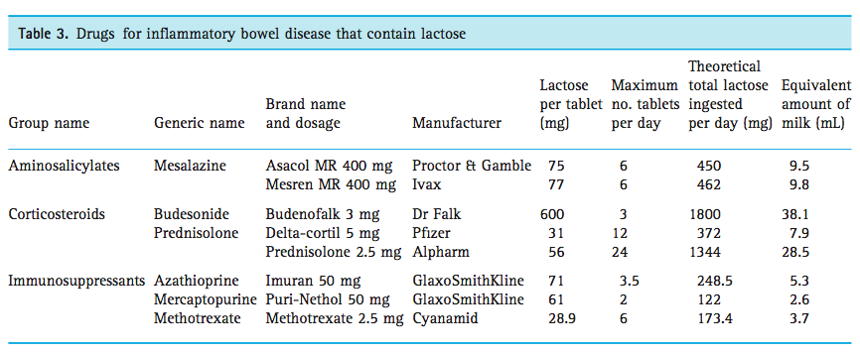

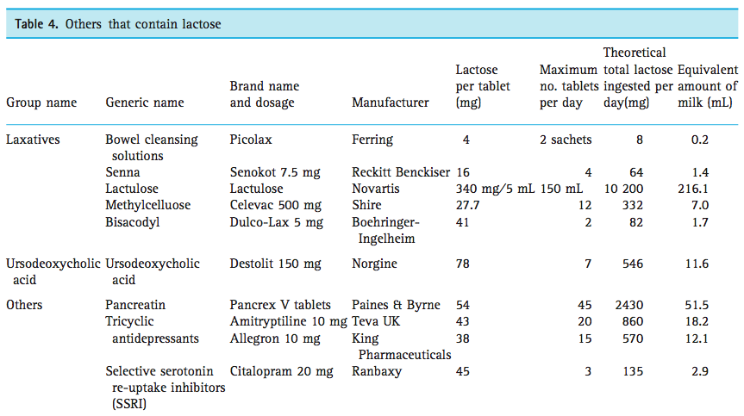
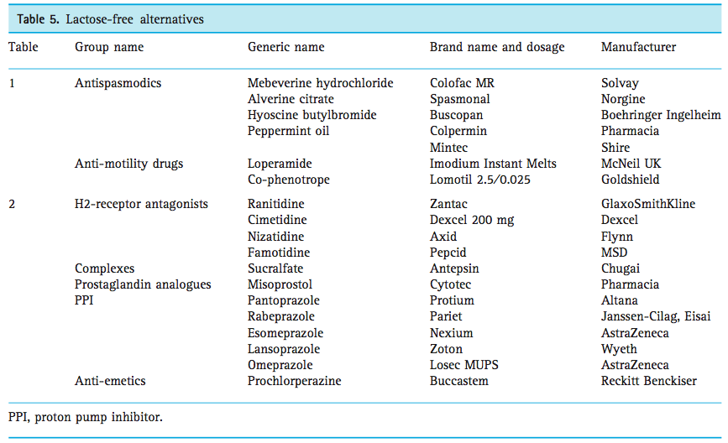
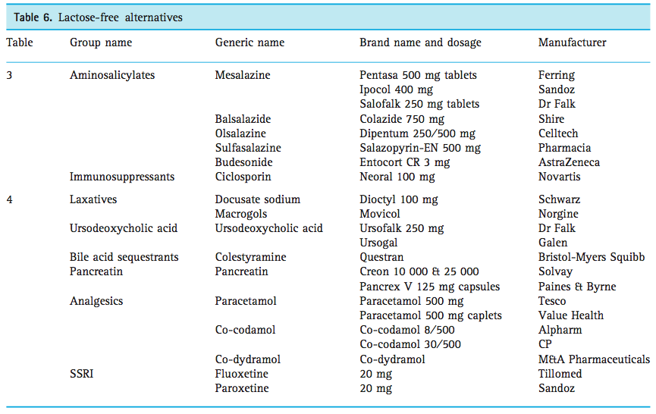
Please note that while the medications listed are lactose-free medications, one must always refer to the official product label or CMI or Product Information sheet to establish lactose content. (Source: Eadala P, Waud JP, Matthews sb, Green JT, Campbell AK. Quantifying the hidden lactose in drugs used for the treatment of gastrointestinal conditions. Aliment Pharmacol Ther 2009, 29(6), 677-687.)

